StarwarsApp by Guillermo Siliuto

Testing DataBase and Json information
- Initialize the application for the first time
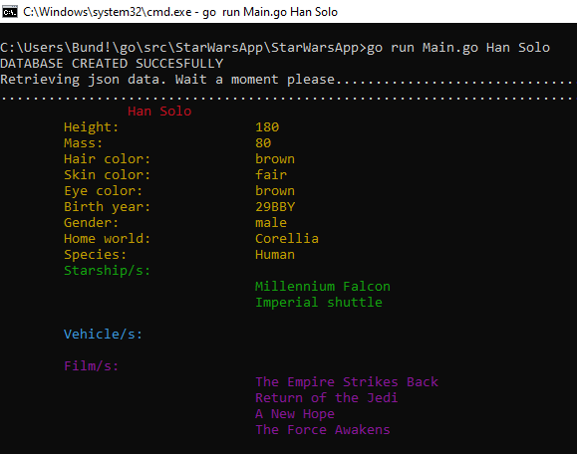
Creates the database and retrieves the information from Json

